


ROUTE 25 - November
Ricardo Abreu
14.11.2025

8.11 November 2025
8.11.1 Technical Activity – QoS Prediction Model Development

Change History
Date | Version | Author | Description
11/11/2025 | 1 | Ricardo Abreu | Onboarding, 8.11.1 - Explorating QWS dataset
12/11/2025 | 2 | Ricardo Abreu | 8.11.1 - Data Exploratory Analysis, Data Processed. Implemented LinReg, Random Forest and XGBoost
13/11/2025 | 3 | Ricardo Abreu | 8.11.1 - Data Profiling, Exploratory Analysis, Data Processed (scripts improvements)
14/11/2025 | 4 | Ricardo Abreu | 8-11-1 - Models Tuning and Evaluation

Table of Contents

Tuesday – 11/11/2025

1. Load and Inspect Data

1.1 Data sources
- Dataset: QWS Dataset V1
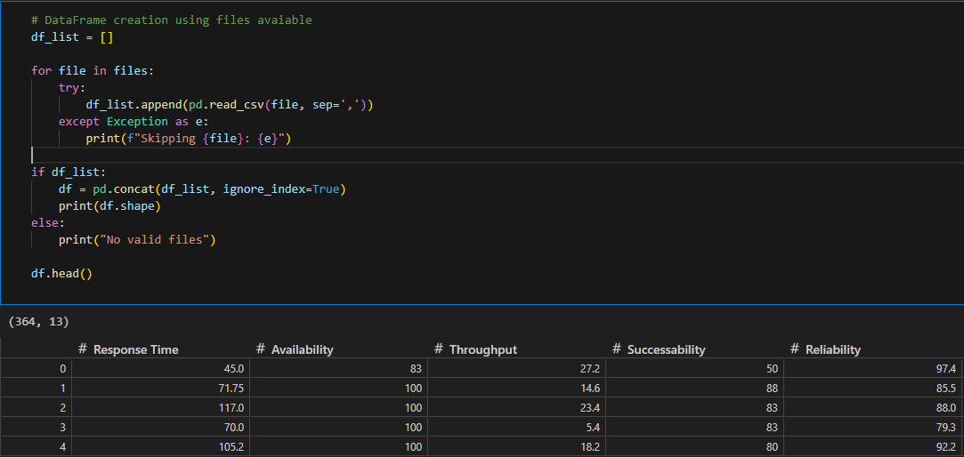
The data source was in .txt format and contained comments and non-standard headers, which required initial cleaning. In this first step, a copy of the file was created, and the first 42 lines—containing only the project description—were removed. Next, a header row with column names was added to match the data structure. The file was then loaded into the local environment for data analysis.

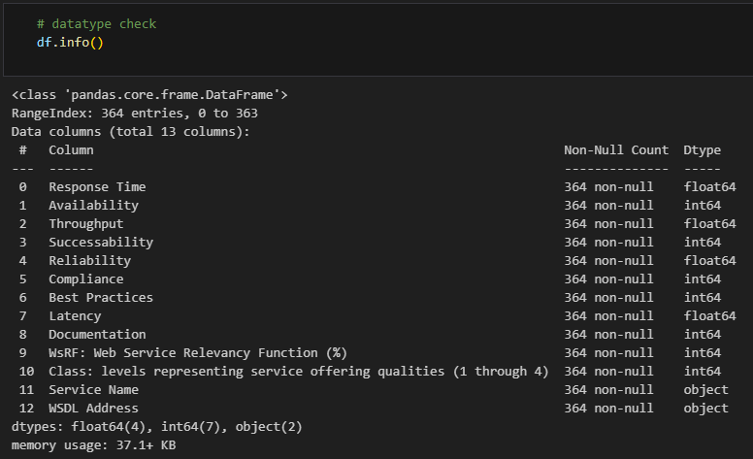
The next phase consisted of exploratory data analysis to gain a deep understanding of the data, metadata, and dataset structure.

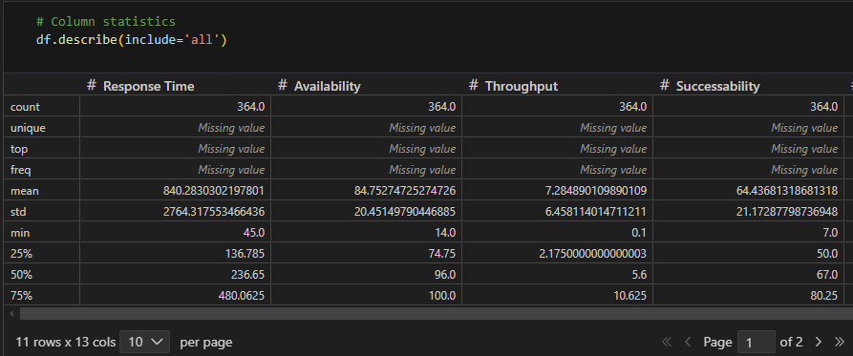
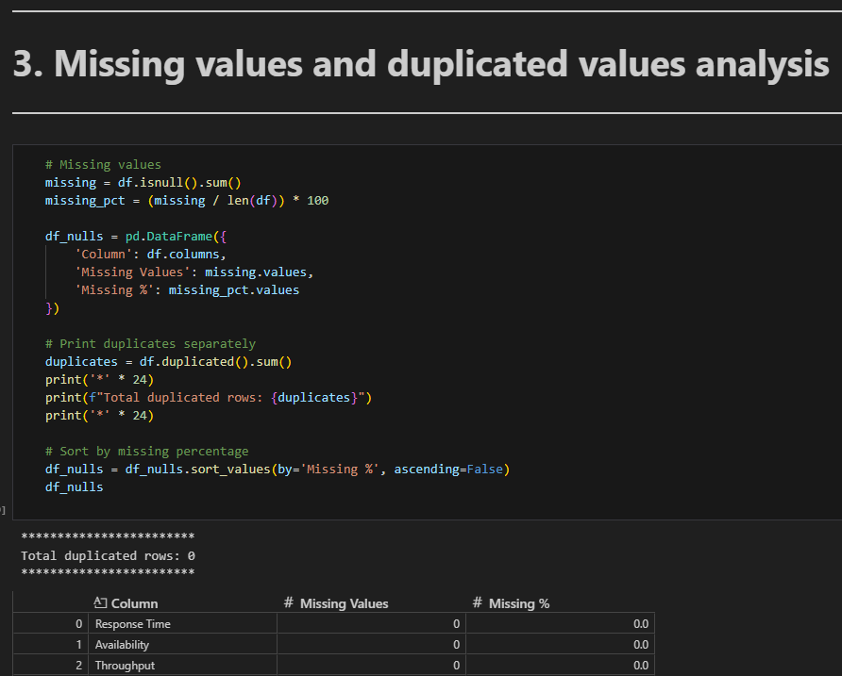
After that, the data was inspected for null values, duplicates, and outliers, following standard procedures for dataset profiling.
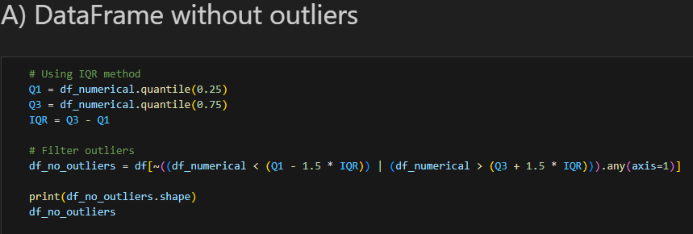

As a final note for this stage, the following points were observed:
- Data types are correct;
- The dataset contains no duplicates or null values;
- The dataset includes some outliers; however, given its small size, these were retained.
- The target variable chosen for prediction is “WsRF: Web Service Relevancy Function (%)”.

Wednesday – 12/11/2025
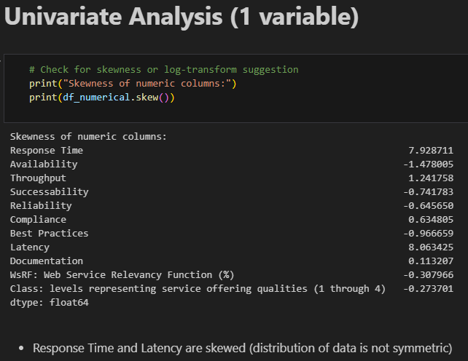
In this phase, a graphical analysis was performed to better understand the data distribution and relationships between variables.
Univariate, bivariate, and multivariate analyses were conducted, considering service classification into predefined categories.

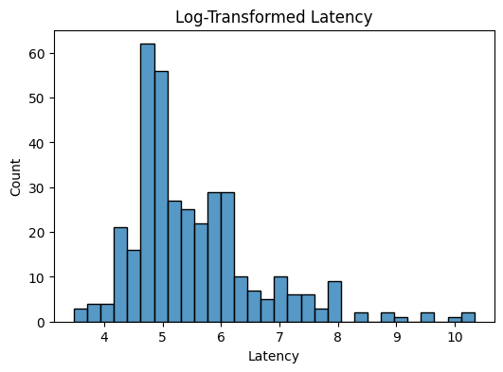
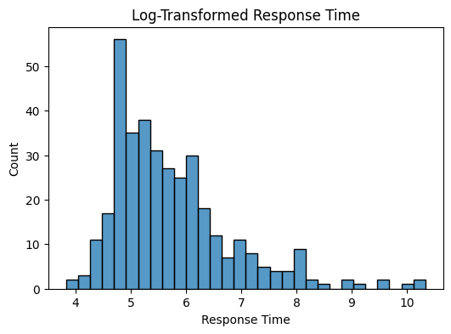
Initially, the variables “Response Time” and “Latency” were explored due to their less symmetric distributions.
Subsequently, the remaining numeric variables were analyzed according to their distribution.

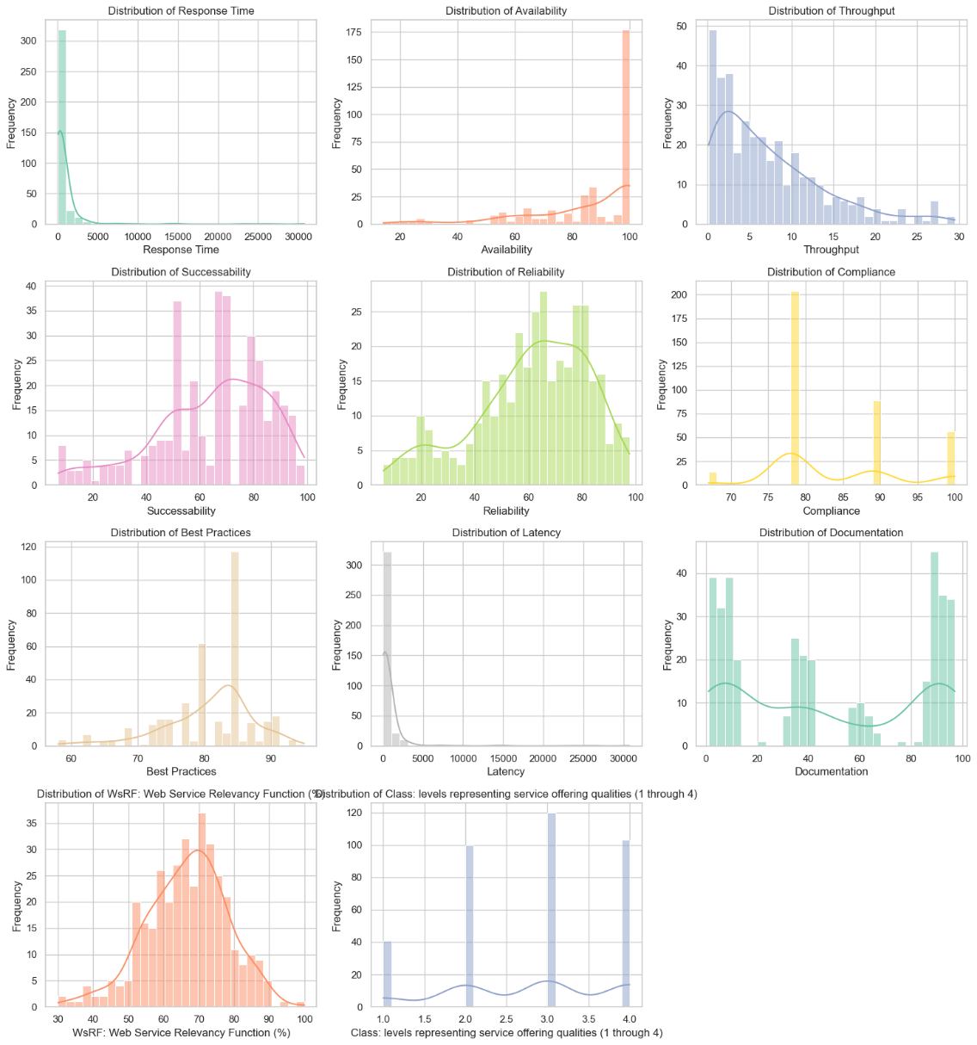
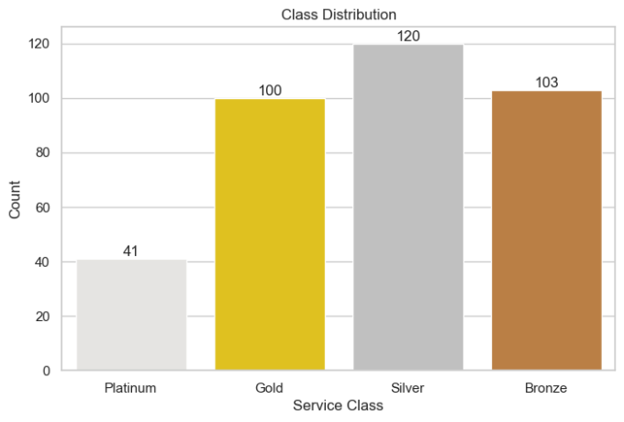

The next step involved creating a correlation matrix during the bivariate analysis to identify patterns among variables.

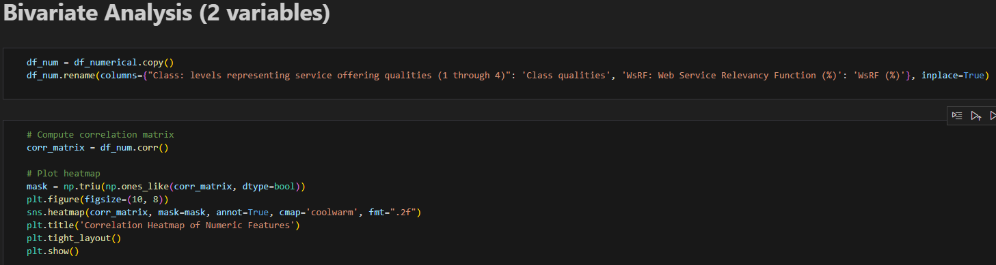
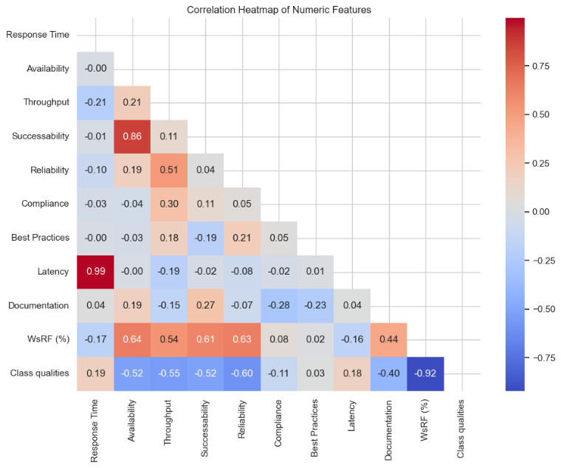
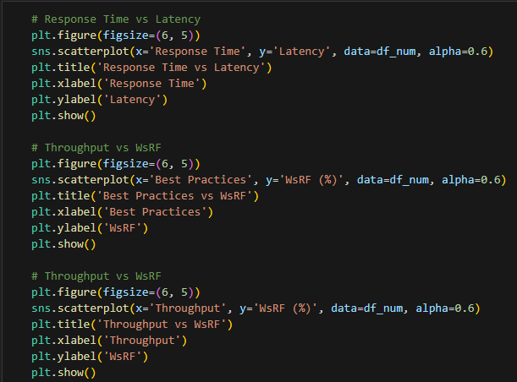
Below is an example of a chart illustrating the decision to drop a variable from the model because it showed no meaningful pattern with the target variable.

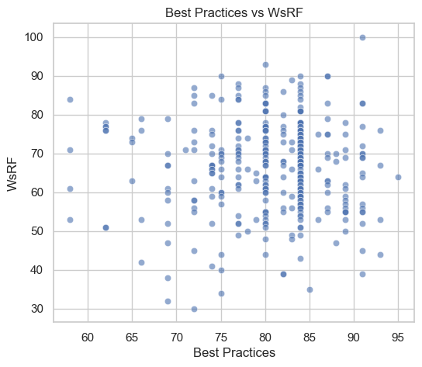
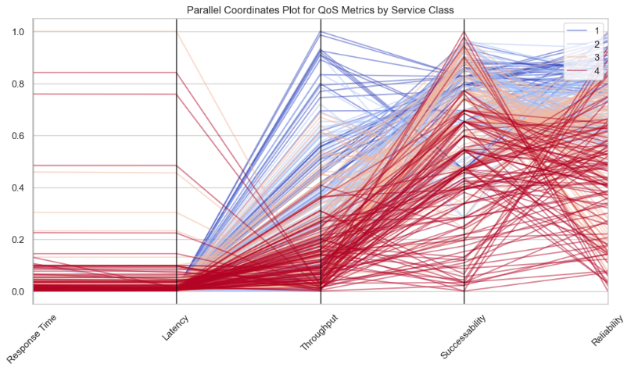
Finally, a brief multivariate analysis was performed to understand how certain characteristics relate to service level.

Key findings from this analysis:
- Univariate Analysis:
  - Availability is concentrated near 100%, suggesting most services are highly available.
  - Successability, Reliability, and WsRF are fairly normal, centered around 50–80.
- Bivariate Analysis:
  - Platinum services (Class 1) generally have lower Response Time and Latency compared to Bronze.
  - Throughput tends to decrease as class level increases (Platinum → Bronze).
  - Reliability and Successability are higher for Platinum and Gold.
  - Response Time and Latency show strong positive correlation (services with high response time also have high latency).
  - Best Practices vs WsRF shows weak correlation, suggesting WsRF may not strongly depend on Best Practices.
  - Response Time and Latency have the highest correlation among numeric features.
  - Availability and Documentation have low correlation with other metrics, indicating limited predictive power.

- Multivariate Analysis:
  - Platinum services cluster with low Response Time and Latency, high Reliability and Successability.
  - Bronze services show the opposite pattern: high delays and lower reliability.
  - Columns that can be dropped - (Latency or Response Time, only one) and Best Practices.

Thursday – 12/11/2025
In this phase, Machine Learning (ML) models were built to train on the data and predict future datasets.
The workflow followed this sequence:
- Split the data into training and test sets.
- Define preprocessing steps. Depending on the model, data transformations may vary.
- Train the model using the training set.
- Evaluate the model on the test set.
- Tune the model (an iterative process to identify the best parameters for improved performance).
Data Splitting:
The figure below illustrates how data was split and columns with low correlation were removed (to reduce noise in the model).
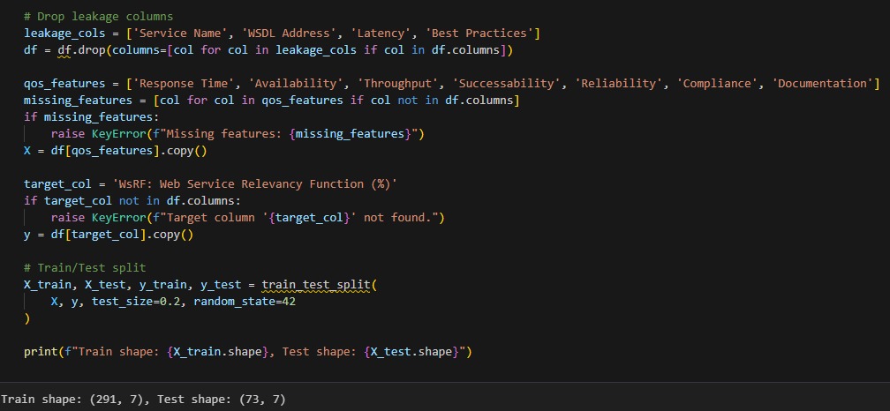

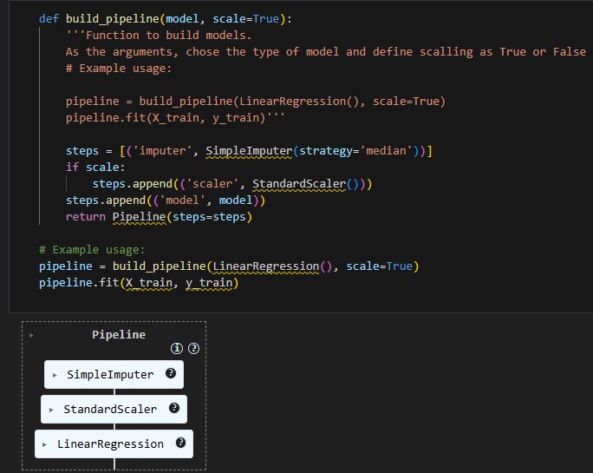

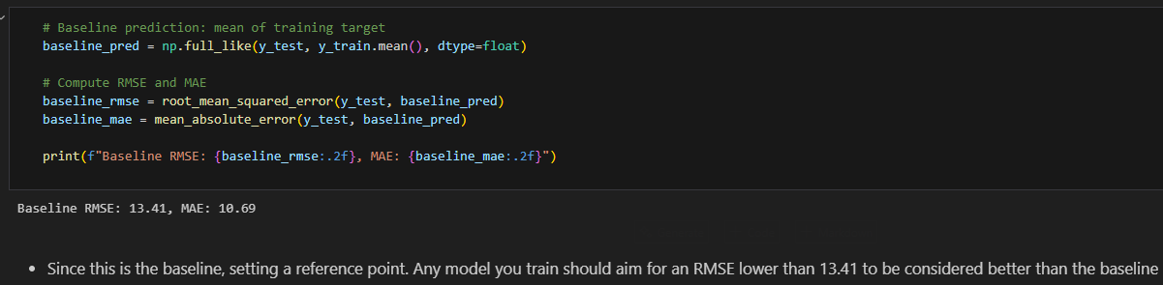
Next, a baseline model was defined for comparison with subsequent models.

The models selected were Linear Regression, Random Forest, and XGBoost.
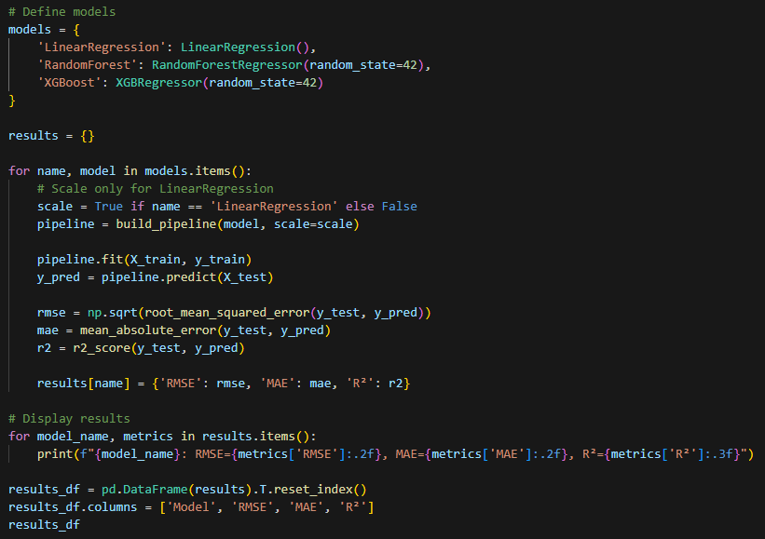
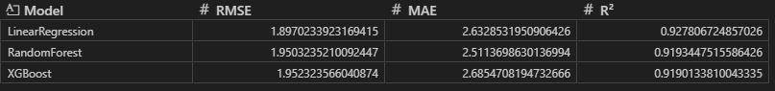

The following table shows the results of all 3 models:
Model | RMSE | MAE | R²
Linear Regression | 1.8970233923169415 | 2.6328531950906426 | 0.927806724857026
Random Forest | 1.9503235210092447 | 2.5113698630136994 | 0.9193447515586426
XGBoost | 1.952323566040874 | 2.6854708194732666 | 0.9190133810043335

2. Model Tuning - RandomizedSearchCV
Nesta secção é descrito como os modelos foram melhorados. Cada modelo tem um algoritmo com hyper-parâmetros ( parâmetros do algoritmo) que podem ser modificados no sentido de melhorar a performance por parte do modelo de ML. Segue o exemplo abaixo para descrever parâmetros que podem ser mudados na Regressão Linear:
Eg. Hyperparameters for Linear Regression:
- - fit_intercept: Whether to calculate the intercept (True/False).
- - positive: Force coefficients to be positive (True/False).
- - normalize: Deprecated in newer versions (use StandardScaler instead).
- - n_jobs: For parallel computation (usually not critical here)
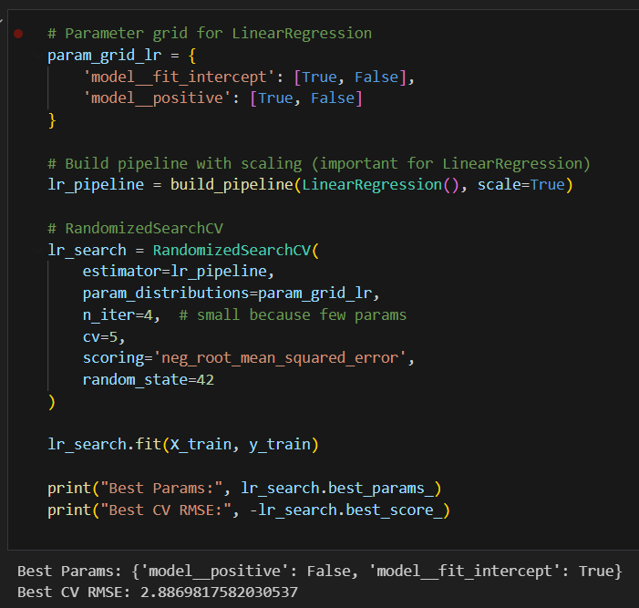

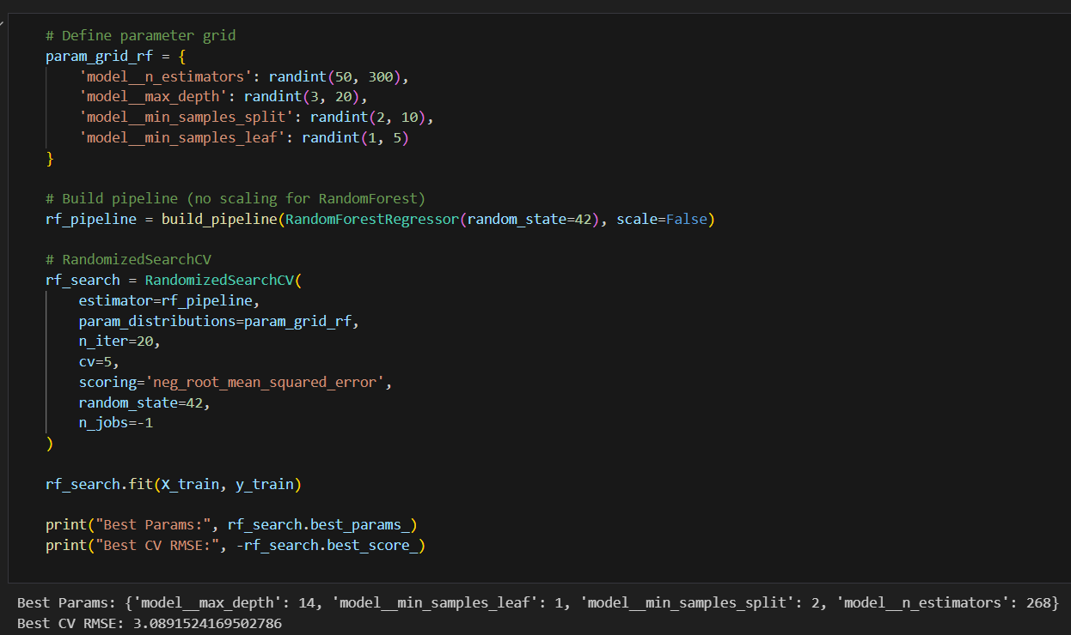
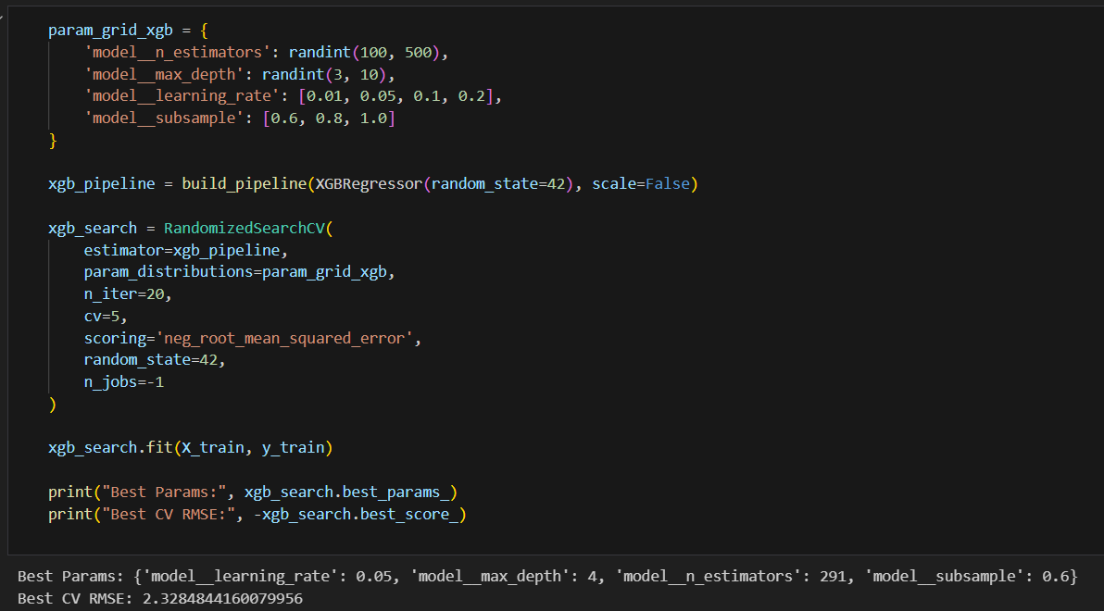
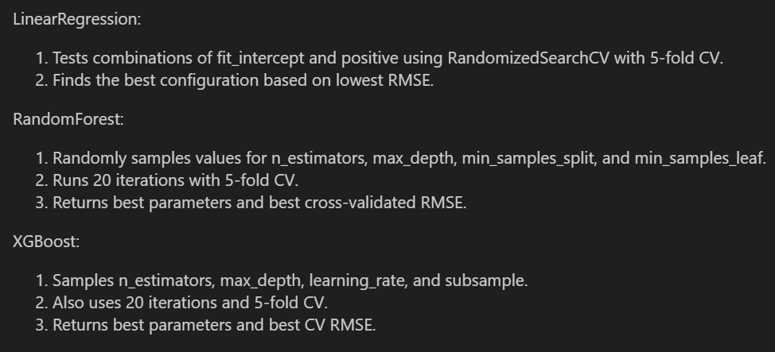
The 3 previous figures are the parameters changed in all 3 models to get the best outcome para each model, as summarized in the next figure:

3. Prediction
This section comes after hyperparameter tuning using RandomizedSearchCV for the three models: Linear Regression, Random Forest, and XGBoost. Each search object (lr_search, rf_search, xgb_search) contains the best configuration found during cross-validation.
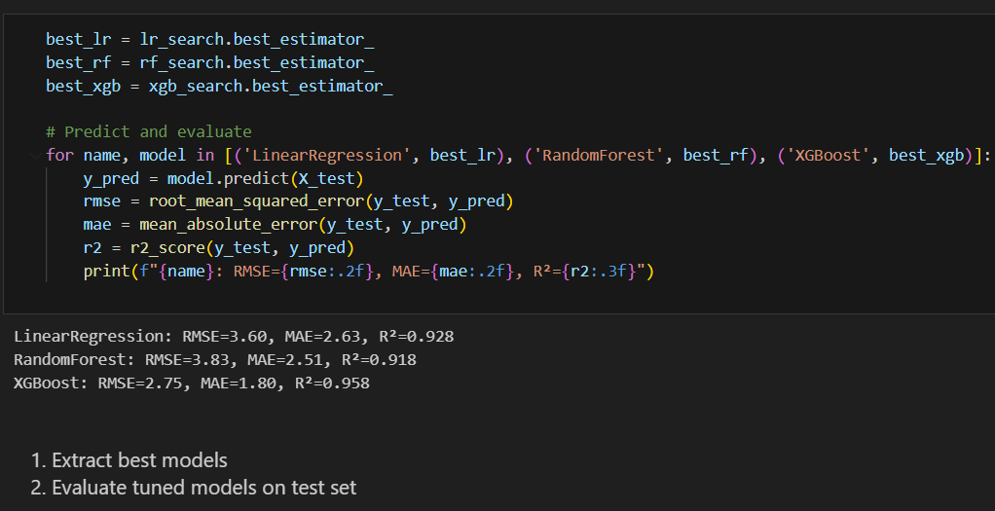

The code presented in the previous picture does the following:
- Iterates over each tuned model with its name for clarity.
- Generates predictions on the test set (X_test), which was held out during training to ensure unbiased evaluation.
- Computes three key metrics:
- RMSE (Root Mean Squared Error): Measures prediction error magnitude. Lower is better.
- MAE (Mean Absolute Error): Measures average absolute deviation. Useful for interpretability.
- R² (Coefficient of Determination): Indicates how much variance in the target is explained by the model. Closer to 1 means better fit.
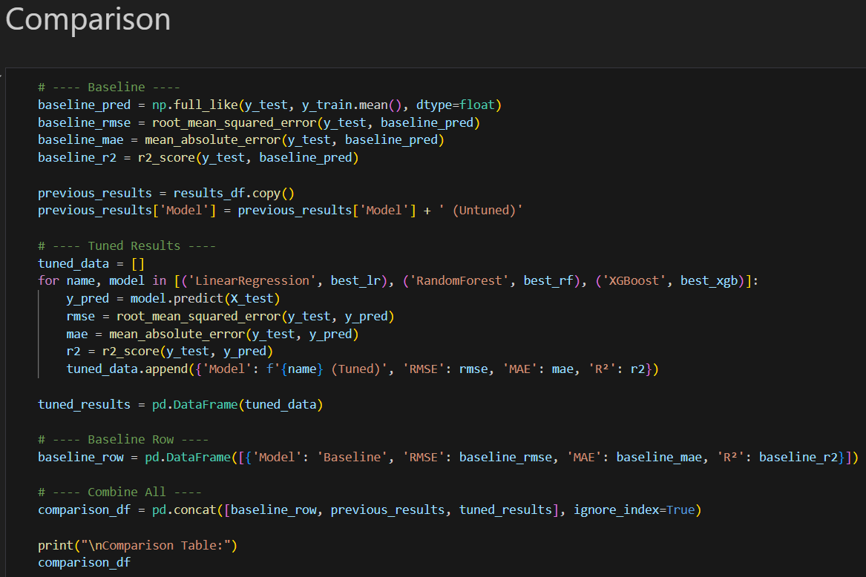
- Prints results.
Then, the results from the tuning of the models, the results from the models there were not tuned and the baseline model were compared, as showed in the previous picture. It’s results are in the following table:
Model | RMSE | MAE | R²
Baseline | 13.408000765060446 | 10.687379372028431 | -0.002153048229032839
Linear Regression | 1.8970233923169415 | 2.6328531950906426 | 0.927806724857026
Random Forest | 1.9503235210092447 | 2.5113698630136994 | 0.9193447515586426
XGBoost | 1.952323566040874 | 2.6854708194732666 | 0.9190133810043335
Linear Regression (tuned) | 3.5986977509976765 | 2.6328531950906426 | 0.927806724857026
Random Forest (tuned) | 3.8263169789963936 | 2.513851973011654 | 0.918385393789493
XGBoost (tuned) | 2.7543282508850098 | 1.8014215230941772 | 0.9577100276947021

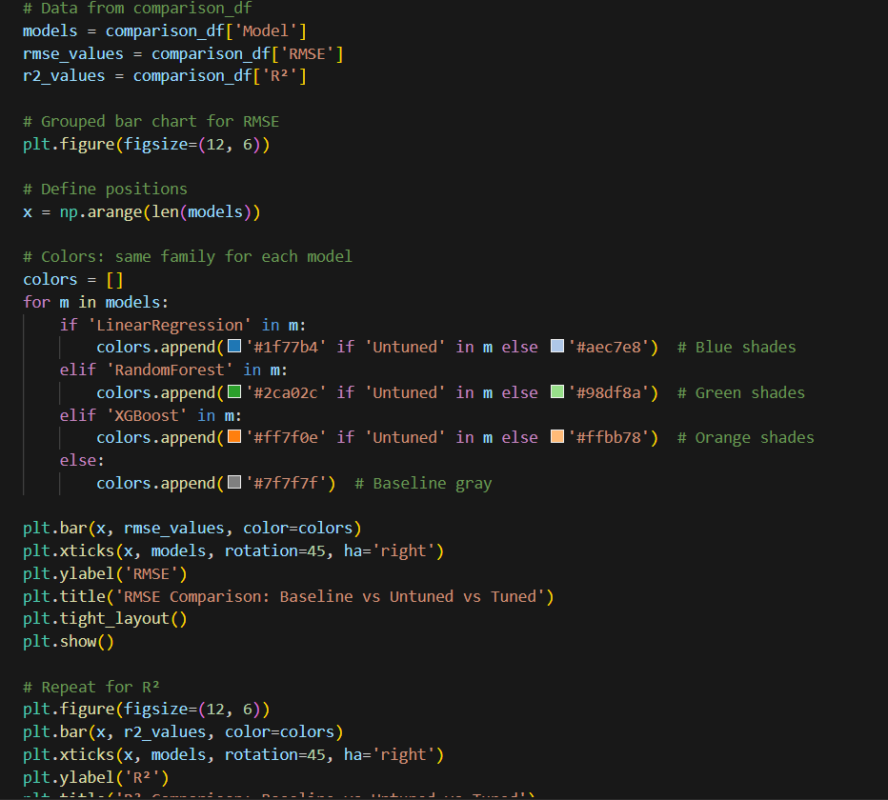
For graphical comparison, the following code was constructed to visualize the results.

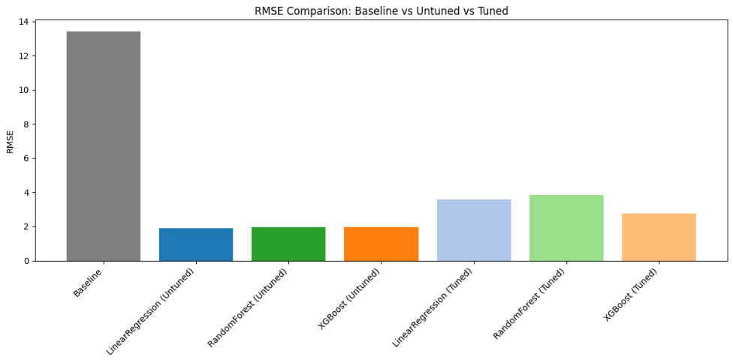
This produced the following:
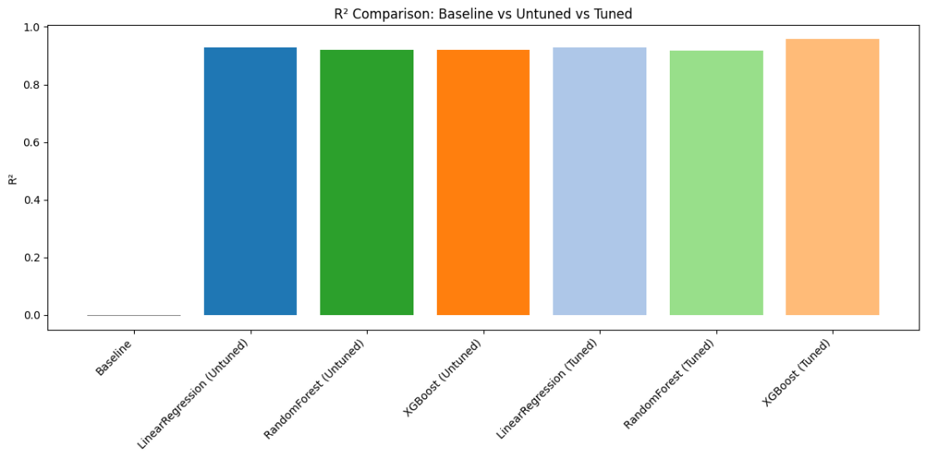

Friday – 11/14/2025

About Capgemini Engineering
World leader in engineering and R&D services, Capgemini Engineering combines its broad industry knowledge and cutting-edge technologies in digital and software to support the convergence of the physical and digital worlds. Coupled with the capabilities of the rest of the Group, it helps clients to accelerate their journey towards Intelligent Industry. Capgemini Engineering has 65,000 engineer and scientist team members in over 30 countries across sectors including Aeronautics, Space, Defense, Naval, Automotive, Rail, Infrastructure & Transportation, Energy, Utilities & Chemicals, Life Sciences, Communications, Semiconductor & Electronics, Industrial & Consumer, Software & Internet.
Capgemini Engineering is an integral part of the Capgemini Group, a global business and technology transformation partner, helping organizations to accelerate their dual transition to a digital and sustainable world, while creating tangible impact for enterprises and society. It is a responsible and diverse group of 340,000 team members in more than 50 countries. With its strong over 55-year heritage, Capgemini is trusted by its clients to unlock the value of technology to address the entire breadth of their business needs. It delivers end-to-end services and solutions leveraging strengths from strategy and design to engineering, all fueled by its market leading capabilities in AI, cloud and data, combined with its deep industry expertise and partner ecosystem. The Group reported 2023 global revenues of €22.5 billion.
Get the future you want | www.capgemini.com


This presentation contains information that may be privileged or
confidential and is the property of the Capgemini Group.
Copyright © 2024 Capgemini. All rights reserved.

